**Table of Contents**

1 INTRODUCTION 1

1.1 Material Handling Costs 4

1.2 Goals 4

1.3 Objectives 5

2 LITERATURE REVIEW 7

2.1 Design, Development And Analysis Active Gravity Conveyor For Flexible Manufacturing Using Karakuri Mechanism 7

2.2 Design And Selecting The Proper Conveyor-Belt 7

2.3 Materials Handling 8

2.4 A Review On Material Handling Equipment And Their Selection For Potential Applications 8

2.5 Material Handling Equipment 9

2.6 Materials handling in flexible manufacturing systems 10

2.7 Analysis And Optimization Of Gravity Roller Conveyor Using Ansys 11

2.8 Design And Analysis Of A Roller Conveyor For Weight Optimization & Material Saving 11

2.9 An investigation into design and manufacturing of mechanical conveyors systemsfor food processing 12

2.10 Design and Optimization of Roller Conveyor System 12

3 PRINCIPLES OF MATERIAL HANDLING 13

3.1 Objectives of Material Handling 14

3.2 Reduce Cost of Handling 14

3.3 Reduced Manufacturing Cycle Time 15

3.4 Scope of Material Handling 15

3.5 Characteristics of Materials 15

3.6 Factors for Consideration in Material Handling System Design 16

3.6.1 Material 16

3.6.2 Move 16

3.6.3 Methods 16

3.7 Power Savings As Compared To Conveyors 16

3.7.1 Conveyor 17

3.7.2 Operations 17

3.7.3 Cost 18

4 DESIGN CONCEPT 19

4.1 Working 19

4.2 Mathematical Analysis 21

5 SYSTEM COMPONENTS 24

5.1 Bearing Housing 24

5.2 Main Shaft 25

5.3 Hinge Nut and Bolt 25

5.4 Bearings 25

5.5 Damper Bracket and spring 25

5.6 Base and Base Plate 25

5.7 Tray and Counterweight 25

6 CAD DESIGN AND DRAFTING 27

6.1 3-D Modeling Using Solidworks 27

6.2 Benefits 27

7 MATERIAL SELECTION 29

7.1 Design Of Main Shaft 30

7.2 Design Of Bearings 31

7.2.1 Bearing 1 31

7.2.2 Bearing 2 32

7.3 Design Of Bearing Block 34

7.4 Design Of Bolt 36

7.4.1 On Tray Side 36

7.4.2 On Counterweight Side 37

7.4.3 Design of Hinge Bolt 39

7.5 Weld Design 40

7.5.1 Countershaft Holder 40

7.5.2 Tray Pipe Holder 41

8 FABRICATION 43

8.1 Process Sheets 43

8.2 Bill Of Material 55

8.3 Cost Estimation 62

9 FUTURE SCOPE 64

9.1 Telescopic Arm 64

9.2 Adjustable Weight 64

9.3 Ceiling Attachment 65

9.4 Combination of Telescopic and Adjustable Counterweight 65

9.5 Automatic Delivery 65

9.6 Modifications of Tray 65

10 ADVANTAGES AND APPLICATION 66

10.1 Advantages 66

10.2 Applications 66

11 CONCLUSION 67

12 REFERENCES 68

**Table of Figures**

Fig. 3.1 Position 1 AND 2 13

Fig. 4.1 BEARING HOUSING 18

Fig. 5.1 BENEFITS 22

Fig. 6.1 DESIGN OF MAIN SHAFT 24

Fig. 6.3 DESIGN OF BEARINGS 28

Fig. 6.4 DESIGN OF BEARING BLOCK 29

Fig. 6.5 DESIGN OF BOLT 30

Fig. 6.6 Design of Hinge Bolt 33

Fig. 6.7 WELD DESIGN 34

Fig. 6.8 Tray Pipe Holder 35

Fig. 7.1 BILL OF MATERIAL 49

Fig. 7.2 Bearing Block 51

Fig. 7.3 Base Assem 51

Fig. 7.4 CW Assembly 52

Fig. 7.5 Base 52

Fig. 7.6 Casing Plate 53

Fig. 7.7 CW Shaft Holder 53

Fig. 7.8 Tray Pipe Holder 54

Fig. 7.9 Tray Pipe 54

Fig. 7.10 Main Shaft 55

Fig. 8.1 TELESCOPIC ARM 58

Fig. 8.2 ADJUSTABLE WEIGHT 58

**List of Tables**

Table 2.1 11

Table 2.2 11

Table 2.3 12

Table 3.1 17

Table 7.1 37

Table 7.2 38

Table 7.3 39

Table 7.4 40

Table 7.5 41

Table 7.6 42

Table 7.7 43

Table 7.8 44

Table 7.9 45

Table 7.10 46

Table 7.11 47

Table 7.12 48

Table 7.13 50

Table 7.14 56

Table 7.15 56

# INTRODUCTION

Handling of the raw material during the production of any product is relatively very important process. The material passing through special stages of the fabrication process. A particular material is utilized in the particular stage of the production. It is always important to store, transport, and make available the material for achieving the targets of the production.

Any production line requires completing the given task in given stipulated time. The process will be very effective if the material reaches to the particular place of its utilization during shortest possible time. The minimization of the time required for this process gives better effective performance in terms of improved per unit production during the stipulated time. This leads to better production and profit to the organization.

Moving the material with the controlled movement is achieved best by the conveyor system. This movement of the material is from one department to other or between the two separated processing units of the production line. The effective handling process of the material reduces the cost of production there by reducing the handling cost of the material. Saving the cost due to effective handling gives better per unit cost saving. The reduced efforts by implementation of this system improve the efficiency of the system.

Automation is always preferred as it avoids the human errors and works very effectively. Generally the automation is useful to reduce the human efforts in the repetitive tasks of the industrial processes. Authors have cognizant to present the gravity based arrangement for the conveyors. The intended system has confirmed its usefulness in the movement of the matter for better handling. The weight when placed in particular place results in the movement as shown in figures below.

**Right Amount**: Because of JIT, production lot sizes have been reduced significantly and the amount and the cost of inventory are reduced. Contrary, in order to reduce the cost of handling, the size of the unit load should be increased. Note that the right amount is not zero. In determining the right amount of material to stock in a warehouse, it is often required to determine the right amount to stock in the active picking area and the right amount to provide as safety stock.

**Right** M**aterial**: The two most common errors made in order picking are, picking the wrong amount and picking the wrong material. For Material Handling System to store, move, protect and control the right material, an accurate identification system must be included. Automatic identification is the key of accurate identification. The rapid production of bar coding technology, the emergence and maturation of radio frequency identification, and the continued development of magnetic and other identification technologies make it possible to provide the right material consistently. Reduce the number of part numbers by standardization and removing obsolete parts from the database. Finally, it is important to recognize that moving, storing, protecting, and controlling the right material requires a decision as to which material to move, store, protect, and control. Not all material has to be controlled in the same way. Infrequently used low value material does not require the same degree of control as frequently used high value material.

**Right Condition**: The first thing that comes to mind is top quality, and the absence of damage. If quality is what the customer says it is, then we must identify the customers of the handling system. But, quality is not all that the right material means. Also, we are concerned about the status of material (its location, processing steps those have been performed, its physical characteristics, its availability for shipment, and the need for tests or inspections). It is important to confirm what each customer requires in terms of the condition of the material served by the handling system.

**Right Place**: When material arrives, often it is placed in more than one “temporary” locations or staging points before it is eventually placed in storage. Instead of whether material has assigned or randomized storage locations, it should be placed in the right location (place). It is also important for material locations to be entered quickly and accurately in the locator system. When material arrives on the manufacturing floor, it is placed one on another as a stack on the floor or placed in “buffers”, awaiting further processing. The decisions should be made regarding whether central storage or distributed storage is best for a particular application. In the design of workstation, from an ergonomics point of view, material should be placed within easy reach; hence, stooping, bending, and stretching of operator should be avoided. This also applies for the assignment of material to storage locations for an order picker. While there might be more than one right place for material, the number of wrong places exceeds the number of right places. Aisle cannot be a right place for material to be stored, staged or queued.

**Right Time**: The need for the material handling system at the right time is increasingly important due to time-based competition. Quick response systems reduce the time required to manufacture and deliver products to customers. In order for the material handling system to be able to satisfy the requirements for timely responses, excess capacity in the system is generally required. Cycle-time reduction is a primary target in continuous improvement programs, Total Quality Management (TQM), places considerable emphasis on reducing non-value-adding activities in the process. The notion of supply chain management hinges on reducing the length of the supply pipeline by reducing the time required to move, store, protect, and control the material throughout the pipeline. Although we advocated shorter overall system time, we did not advocate using faster equipment. Being to soon can be worse than being too late in material handling. The emphasis is on the right time, not the fastest time.

**Right Position/Orientation**: Machined parts are dumped into tote boxes; subsequently someone sorts out the parts and rearranges them for the next operation. Physical orientation is often accommodated by changing the design of a part, by adding locator holes or pins, automatic orientation of parts might become feasible. Not only do parts and cases need to be oriented properly, but so do palletized loads. It is important for MH System designer to maintain the proper orientation of unit loads as they make right-angle transfers on a conveyor system.

**Right Sequence**: Work simplification teaches that productivity can be increased by eliminating unnecessary steps in an operation and improving those that remain. Also, productivity improvement can occur by combining steps and changing the sequence of steps performed. The impact of the sequence of activities performed on the efficiency of an operation is very evident in material handling. An opportunity for systems improvements through sequence changes is often the design of the control system

**Right Cost**: Remember, the objective of the firm is to maximizes the value provided to the shareholders; it is not to achieve a minimum cost of MH. The right cost is not necessarily the lowest cost. MH System can be a revenue enhancer, rather than a cost contributor. Today, firms compete on the basis of product functionality, product quality, service quality, time, and cost. To do so, the MH System must be both effective (does the right things) and efficient (does things right). Although, a significant percentages of direct labor time is devoted to material handling, generally, the majority of the material handling cost is buried in a firm’s overhead costs. In measuring such costs, both costs incurred (investment and operating costs for MH technology and personnel) and costs foregone (costs of inventories, space, inspectors, expeditors, and other personnel not needed because of the installation of the MH System) should be measured. Reduction in losses due to damage and pilferage need to be included.

**Right Methods**: Finally, to do all the right things right, we need to employ the right methods. But, the right method is not necessarily the most sophisticated method, the newest method, or the least expensive method. Simply stated, a method is right if it satisfies the requirements of providing the right amount of the right materials, in the right condition, in the right sequence, in the right orientation, at the right place, at the right time, and at the right cost. MH is much more than simply MH. Material Handling is an art and a science, that involves the movement, storage, control, and protection of material, with the objective of providing time and place utility.

## Material Handling Costs

The main costs involved in designing and operating a Material Handling System are:

* Equipment cost, comprises the purchasing of the equipment and auxiliary components, and installations
* Operating cost, includes maintenance, fuel, and labor cost, consisting of both wages and injury compensation
* Unit purchase cost, is associated with purchasing the pallets and containers
* The Cost due to which packaging and damaged material.

## Goals

The primary goal of material handling is to reduce overall unit costs of production.

The following subordinate goals are a good check-list for cost reduction:

* Maintain or improve product quality, reduce damage, and provide for protection of materials
* Promote safety and improve working conditions,
* Promote productivity through
* Material should flow in a straight line
* Material should move as short distance as possible
* Use gravity. It is free power
* Move more material at one time
* Mechanize material handling
* Automate material handling
* Improve or Maintain material handling/production ratios
* Using automatic material handling equipment, increase throughput
* Promote increased use of facilities by
* Promote the use of the building cube
* Purchase versatile equipment
* Standardize material handling equipment
* Increase production equipment utilization using material handling feeders
* Maintain, and replace as needed, all equipment and develop a preventive maintenance program
* Integrate all material handling equipment into a system
* Reduce tare (dead) weight
* Control inventory

## Objectives

The major objective of MH System design is reducing production cost through efficient handling or, more specifically:

* To increase the efficiency of material flow by ensuring the availability of materials when and where they are needed.
* To reduce material handling costs.
* To improve facilities utilization.
* To improve safety and working conditions.
* To facilitate the manufacturing process.
* To increase productivity

# LITERATURE REVIEW

## Design, Development and Analysis Active Gravity Conveyor for Flexible Manufacturing Using Karakuri Mechanism

The desire to increase productivity can effectively accomplished through the adoption of low cost automation by their characteristic small and medium size companies. The concept and principles of low cost automation are basically the same as those of full automation except that the former builds improvement around existing equipment and machine system rather than replacing whole system with automated processes. The primary activity of every manufacturing organization is material handling. It has been estimated that at least 15 to 25% of the cost of the product is attributable to material handling activities. Length of conveyor is to be adjustable to be able to connect any two machines spaced between 1 m to 1.8 m. also weight carrying capacity of conveyor to be varied from 5 kg to 12 kg in tray system. Karakuri mechanisms use a single force or motion to simultaneously perform multiple operations also lead directly to energy conservation and resource (facilities) savings. The proposed Active gravity conveyor for flexible manufacture system uses the principle of Converting the force from a dropped weight into gear rotation to activate a conveyor thereby saving the cost of motor and electricity. To perform material handling task conventionally gravity conveyors are used but they are more often of fixed layout type with a singular application.

Keywords— gravity conveyor, low cost automation, material handling

Critical Review:

1. The significant part of product cost is consumed by material handling.
2. To save this cost, use the principle of converting the force from a dropped weight into gear rotation to activate a conveyor.

AIM and Objectives:

Determine the material handling cost.

Problem Statement:

## Design and Selecting the Proper Conveyor-Belt

Belt conveyor is the transportation of material from one location to another. Belt conveyor has high load carrying capacity, large length of conveying path, simple design, easy maintenance and high reliability of operation. Belt Conveyor system is also used in material transport in foundry shop like supply and distribution of molding sand, molds and removal of waste. This paper provides to design the conveyor system used for which includes belt speed, belt width, motor selection, belt specification, shaft diameter, pulley, gear box selection, with the help of standard model calculation.

Critical Review:

1. Using gravity based conveyor belts, it reduces cost of electricity. It has easy maintenance compared to electric based conveyors.
2. They are mostly used in supply and distribution industry.

AIM and Objectives:

Calculate the belt speed, belt width, shaft diameter with the help of standard model calculation.

Problem Statement:

## Materials Handling

A very warm welcome to all of you in this lecture on materials handling over the past couple of days we have been having lectures related to the different topics of industrial engineering. Materials handling is also one of the most important aspects to be considered whenever we design a manufacturing plant. We have to see that the materials handling should be easy it should be cost effective and it should be very efficient. So, in today’s lecture we will see that what are the salient features of materials handling? What are the various definitions of materials handling? What are the objectives of materials handling? When, we have to design a material handling plant like, when we have to take a decision regarding the material handling systems then we will see, what are the principles of material handling, and finally, we will see that if we go for an automated handling system what are the limitations of such a process. So, basically the important point to realize here is that material handling is an important aspect. And it has to be looked into if we want to make profit. Basically, profit maximization is the main or the soul, aim of the any manufacturing activity. Now, if we spend too much of money of in material handling or our material handling systems are not efficient, not effective too much of time is wasted in taking the material from one to place to another place or the breakdowns are very frequent in those cases the overall manufacturing activity stops and we run into losses. So, it is important to understand that material handling is an important aspect of any manufacturing activity. Here, I am talking about manufacturing because in most of our lectures our focus has been towards manufacturing, but material handling is not at all lying between the domains of manufacturing activity only. It has its scope in a large number of other fields as well so, by the end of this lecture we will see that what the scope of material is handling. So; now, let us start our discussion with a slight introduction to material handling. Material handling means providing the right amount of the right materials

## A Review on Material Handling Equipment and Their Selection for Potential Applications

The material handling system ensures the timely delivery of desired quantity of material at desired location with minimum cost and maximum safety. Material handling is not a manufacturing process but involve substantial amount of product cost and labor. Due to daily invention of new technologies material-handling equipment are undergoing continuous automation. Wide ranges of material handling equipment are available in the market and it is difficult to select best one for industries requirement. A material handling system should be chosen in such away so that to reduce manufacturing cost and avoid interruption and damage. On the other side right selection and planning of MH improves productivity, efficiency and profit of a company. This paper focuses on the classification of material handling systems. The challenges in selecting material handling systems are discussed. In this paper an attempt is made to set some guidelines for selecting the best material handling system for a particular task out of available ones.

Critical Review:

1. There is a range of equipment which are made for material handling purpose. The selection of material handling equipment is very much important, as it has significant impact of cost to company.

AIM and Objectives:

Analyze the specifications of material handling equipment, its productivity and efficiency.

Problem Statement:

## Material Handling Equipment

Material handling (MH) involves “short-distance movement that usually takes place within the confines of a building such as a plant or a warehouse and between a building and a transportation agency”. It can be used to create “time and place utility” through the handling, storage, and control of material, as distinct from manufacturing (i.e., fabrication and assembly operations), which creates “form utility” by changing the shape, form, and makeup of material. It is often said that MH only adds to the cost of a product, it does not add to the value of a product. Although MH does not provide a product with form utility, the time and place utility provided by MH can add real value to a product, i.e., the value of a product can increase after MH has taken place; for example:

• The value (to the customer) added by the overnight delivery of a package (e.g., Federal Express) is greater than or equal to the additional cost of the service as compared to regular mail service—otherwise regular mail would have been used.

• The value added by having parts stored next to a bottleneck machine is the savings associated with the increase in machine utilization minus the cost of storing the parts at the machine.

A common approach to the design of MH systems (MHSs) is to consider MH as a cost to be minimized. This approach may be the most appropriate in many situations because, while MH can add real value to a product, it is usually difficult to identify and quantify the benefits associated with MH; it is much easier to identify and quantify the costs of MH (e.g., the cost of MH equipment, the cost of indirect MH labor, etc.). Once the design of a production process (exclusive of MH considerations) is completed, alternate MHS designs are generated, each of which satisfies the MH requirements of the production process. The least cost MHS design is then selected. The appropriateness of the use of MHS cost as the sole criterion to select a MHS design depends on the degree to which the other aspects of the production process are able to be changed. If a completely new facility and production process is being designed, then the total cost of production is the most appropriate criterion to use in selecting a MHS—the lowest cost MHS may not result in the lowest total cost of production. If it is too costly to even consider changing the basic layout of a facility and the production process, then MHS cost is the only criterion that need be considered. In practice, it is difficult to consider all of the components of total production cost simultaneously, even if a new facility and production process is being designed. Aspects of the design that have the largest impact on total cost are at some point fixed and become constraints with respect to the remaining aspects of the design.

## Materials handling in flexible manufacturing systems

Material handling can be defined as an integrated system involving such activities as moving, handling, storing and controlling of materials by means of gravity, manual effort or power activated machinery. Moving materials utilize time and space. Any movement of materials requires that the size, shape, weight and condition of the material, as well as the path and frequency of the move be analyzed. Storing materials provide a buffer between operations. It facilitates the efficient use of people and machines and provides an efficient organization of materials. The considerations for material system design include the size, weight, condition and stack ability of materials; the required throughput; and building constraints such as floor loading, floor condition, column spacing etc. The protection of materials include both packaging and protecting against damage and theft of material as well as the use of safeguards on the information system to include protection against the material being mishandled, misplaced, misappropriated and processed in a wrong sequence. Controlling material includes both physical control as well as status of material control. Physical control is the orientation of sequence and space between material movements. Status control is the real time awareness of the location, amount, destination, origin, ownership and schedule of material. Maintaining the correct degree of control is a challenge because the right amount of control depends upon the culture of the organization and the people who manage and perform material handling functions. Material handling is an important area of concern in flexible manufacturing systems because more than 80 % of time that material spends on a shop floor is spent either in waiting or in transportation, although both these activities are non-value added activities. Efficient material handling is needed for less congestion, timely delivery and reduced idle time of machines due to non-availability or accumulation of materials at workstations. Safe handling of materials is important in a plant as it reduces wastage, breakage, loss and scrapes etc.

## Analysis and Optimization of Gravity Roller Conveyor Using Ansys

The main objective of this study is to explore the analysis of Gravity roller conveyor. This has entailed performing a detailed Study of existing Gravity Roller Conveyor system and optimize the critical part like roller, C-channel etc. by using composite material, so to minimize the overall weight of the assembly without hampering its structural strength. A proper Finite Element Model is developed using Cad software Pro/E Wildfire 5. Results of Static, Modal and Transient analysis of existing design and optimized design are compared. The material used for roller and C-channel frame is a composite material i.e. carbon fiber. KEYWORDS: structural strength, material handling systems, optimized design, weight reduction, composite material, FEA.

## Design and Analysis of a Roller Conveyor for Weight Optimization & Material Saving

The semi-finished material has to be transported from one station in the assembly to another at a distance of up to 30 meters or more. The method of manual transport by fork-lift is time consuming. A mechanism for continuous and uninterrupted transport is desired.

Conveyor is used in many industries to transport goods and materials between stages of a process. Using conveyor systems is a good way to reduce the risks of musculoskeletal injury in tasks or processes that involve manual handling, as they reduce the need for repetitive lifting and carrying. Conveyors are a powerful material handling tool. They offer the opportunity to boost productivity, reduce product handling and damage, and minimize labor content in a manufacturing or distribution facility. Conveyors are generally classified as either Unit Load Conveyors that are designed to handle specific uniform units such as cartons or pallets, and Process Conveyors that are designed to handle loose product such as sand, gravel, coffee, cookies, etc. which are fed to machinery for further operations or mixing. It is quite common for manufacturing plants to combine both Process and Unit Load conveyors in its operations. Roller conveyor is not subjected to complex state of loading still we found that it is designed with higher factor of safety. If we redesigned critical parts eg. Roller, Shaft, Bearing& Frame etc then it is possible to minimize the overall weight of the assembly. Powered belt conveyors are considerable long (9000 meter to 10000 meter) as compared to roller conveyor. So we can achieve considerable amount of material saving if we apply above study related to roller conveyor to this belt conveyor ‘Finite Element Method’ is a mathematical technique used to carry out the stress analysis. In this method the solid model of the component is subdivided into smaller elements. Constraints and loads are applied to the model at specified locations. Various properties are assigned to the model like material, thickness, etc. The model is then analyzed in FE solver. The results are plotted in the post processor. The scalar plot shows us the stresses and deformations over entire span.

## An investigation into design and manufacturing of mechanical conveyors systems for food processing

This paper presents the results of a research investigation undertaken to develop methodologies and techniques that will reduce the cost and time of the design, manufacturing and assembly of mechanical conveyor systems used in the food and beverage industry. The improved methodology for design and production of conveyor components is based on the minimisation of materials, parts and costs, using the rules of design for manufacture and design for assembly. Results obtained on a test conveyor system verify the benefits of using the improved techniques. The overall material cost was reduced by 19% and the overall assembly cost was reduced by 20% compared to conventional methods.

**Keywords** Assembly · Cost reduction · Design · DFA · DFM ·Mechanical conveyor

## Design and Optimization of Roller Conveyor System

In this paper we studied existing conveyor system and optimized critical parts of roller conveyor system like Roller, C-channels for chassis and support, to minimize the overall weight of assembly and material & cost saving. Paper contains geometrical modeling and finite element modeling of existing design and optimized design. Geometrical modeling is done using Catia V5R19 and finite modeling was done with the help of Ansys .Results shows safe design of optimized design. Optimization gives optimum design for same loading condition with huge amount of weight reduction. Using optimized procedure and using practical available structure 39.26% weight reduction is achieved Key Words: Optimized design, Weight reduction, cost reduction, optimization technique and material handling systems.

# PRINCIPLES OF MATERIAL HANDLING

The College Industry Council on Material Handling Education (CICMHE), sponsored by Material Handling Institute Inc., adopted some principles of material handling. Although there are no definite “rules” that can be followed when designing an effective MHS, the following “Ten Principles of Material Handling,” as compiled by the College Industry Council on Material Handling Education (CIC-MHE) in co-operation with the Material Handling Institute (MHI), represent the distillation of many years of accumulated experience and knowledge of many practitioners and students of material handling:

1 **Planning Principle**: All MH should be the result of a deliberate plan where the needs, performance objectives, and functional specification of the proposed methods are completely defined at the outset.

2 **Standardization Principle**: MH methods, equipment, controls and software should be standardized within the limits of achieving overall performance objectives and without sacrificing needed flexibility, modularity, and throughput.

3 **Work Principle**: MH work (defined as material flow multiplied by the distance moved) should be minimized without sacrificing productivity or the level of service required of the operation.

4 **Ergonomic Principle**: Human capabilities and limitations must be recognized and respected in the design of MH tasks and equipment to ensure safe and effective operations.

5 **Unit Load Principle**: Unit loads shall be correctly sized and configured in a way that achieves the material flow and inventory objectives at each stage in the supply chain.

6 **Space Utilization Principle**: Effective and efficient use must be made of all available (cubic) space.

7 **System Principle**: Material movement and storage activities should be fully integrated to form a coordinated, operational system which spans receiving, inspection, storage, production, assembly, packaging, unitizing, order selection, shipping, and transportation, and the handling of returns.

8. **Automation Principle**: MH operations should be mechanized and/or automated where feasible to improve operational efficiency, increase responsiveness, improve consistency and predictability, decrease operating costs, and to eliminate repetitive or potentially unsafe manual labor.

9**. Environmental Principle**: Environmental impact and energy consumption should be considered as criteria when designing or selecting alternative equipment and MHS.

10. **Life Cycle Cost Principle**: A thorough economic analysis should account for the entire life cycle of all MHE and resulting systems.

## Objectives of Material Handling

The primary objective of a material handling system is to reduce the cost per unit production. The other subordinate objectives are:

* Reduce manufacturing cycle time
* Reduce delays, and damage
* Promote safety and improve working conditions
* Maintain or improve product quality
* Promote productivity
* Material should flow in a straight line
* Material should move as short a distance as possible
* Use gravity
* Move more material at one time
* Automate material handling
* Promote increased use of facilities
* Reduce tare weight
* Control inventory

## Reduce Cost of Handling

The total cost of material handling per unit must decrease. The total cost per unit is the sum of the following:

* Material handling equipment cost - both fixed cost and operating cost calculated as the cost of equipment divided by the number of units of material handled over the working life of the equipment.
* Labor cost - both direct and indirect cost calculated in terms of cost per unit of material handled.
* Cost of maintenance of equipment, damages, lost orders and expediting expenses, also calculated, in terms of cost per unit of material handled.

## Reduced Manufacturing Cycle Time

The total time required to make a product from the receipt of its raw material to the finished state can be reduced using an efficient and effective material handling system.

## Scope of Material Handling

The scope of material handling activity in any industry depends on the type and size of industry, the product manufactured, the value of the product, the value of the activity being performed, and the relative importance of material handling activity to the other activities. However, it should be identified that larger size of total material handling activity is not in manufacturing but in the fields of distribution, agriculture, service industries, and construction. It is very important that both the beginning student and material handling engineer be aware of the material handling applications in the following areas:

* Industrial material handling
* Transportation industries
* Warehousing
* Extractive industries

## Characteristics of Materials

The characteristics of materials affecting handling include the following: size (width, depth, height), shape (round, square, long, rectangular, irregular), weight (weight per item, or per unit volume), and other (slippery, fragile, sticky, explosive, frozen).

Individual units and containerized items ⇒ discrete material flow ⇒ unit loads ⇒ unit handling equipment

Bulk materials ⇒ continuous material flow ⇒ bulk handling equipment

## Factors for Consideration in Material Handling System Design

The material handling system design process is repetitive.

The analyzer has to go back and start different steps until a satisfactory design has been obtained and can be implemented. The major factors for consideration in material handling system design are:

### Material

* Nature – bulk, unit load, individual items, fragile, sturdy, bulky
* Quantity – pieces, pounds, gallons, other
* Characteristics – chemical, electrical, mechanical
* Form – gas, liquid, semi – liquid, solid

### Move

* Source and destination – receiving, stockroom, ware house, same floor, other floor, other department
* Distance – horizontal, vertical, inclined
* Frequency – intermittent, uniform, regular, irregular, unpredictable
* Speed
* Route – location , range, path, cross traffic

### Methods

* Unit or load – bulk, items, containers
* Equipment – conveyor, forklift truck, crane etc.
* Manpower – one, several, many, none

## Power Savings As Compared To Conveyors

The economic analysis of different conveyor systems is explained in the following table. Using conveyor system methodology they found the optimal system for moving thousand parts per minute on a conveyor 100 feet long. The comparison is made between the ‘base’ 14-inch slider belt and the 18-inch roller bed system.

Using the operation cost methodology and program. The number of kilowatt hours is computed for each alternative. Assuming the belt is in operation 10 hours per day for 220 days a year. The annual cost is computed using 5 cents per kilowatt hour. Total cost is given. Slider belt has much greater power consumption

Scheduled maintenance cost of the slider belt system is assumed to be 7.5% of initial system cost. The belt is replaced every 3 years of operation. Roller bed maintenance costs are assumed to be 12% of initial system cost. This higher maintenance cost is due to number of roller in given system. However the belts need replacing in every 8 years. Thus, over 15 year period operating cost of slider bed system is 1.5 times that of operating the roller bed system. Present worth of two systems is shown assuming 12% investment rate and 15 year system life. Hence it is concluded that the operating cost are much greater.

### Conveyor

|  |  |  |
| --- | --- | --- |
| Belt width | 12 inches | 18 inches |
| Support bed | 14- gauge steel slider | 4- inch C roller |
| Drive motor | 1.5 hp | * 1. hp |

Table 2.1

### Operations

|  |  |  |
| --- | --- | --- |
| Belt speed | 25.4 cm/s | 16.916 cm/s |
| Unit load weight | 36.287 kg | 24.176 kg |
| Load weight | 90.718 kg | 1360.777 kg |
| Belt weight | 111.584 kg | 179.894 kg |
| Minimum horsepower | 1.31 hp | 0.52 hp |
| Power | 1.19 kW | 0.50 kW |
| Power consumption/year  ( 10 hrs/day) | 2618 kW-hr/year | 1100kW-hr/year |

Table 2.2

### Cost

|  |  |  |
| --- | --- | --- |
| Initial system cost | 2.5 lac | 2.886 lac |
| Maintenance cost  (Rs/year) | 5 belt replacement  17.77 k | 1belt replacement  34.635 k |
| Electric cost  (Rs/year) | 9.305 k | 3.909 k |

Table 2.3

# DESIGN CONCEPT

## Working

“**The Revolving Material Transfer System**” works on the principle of weights and counterweights.

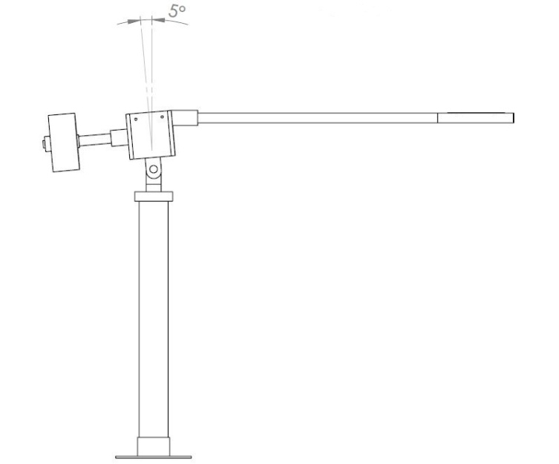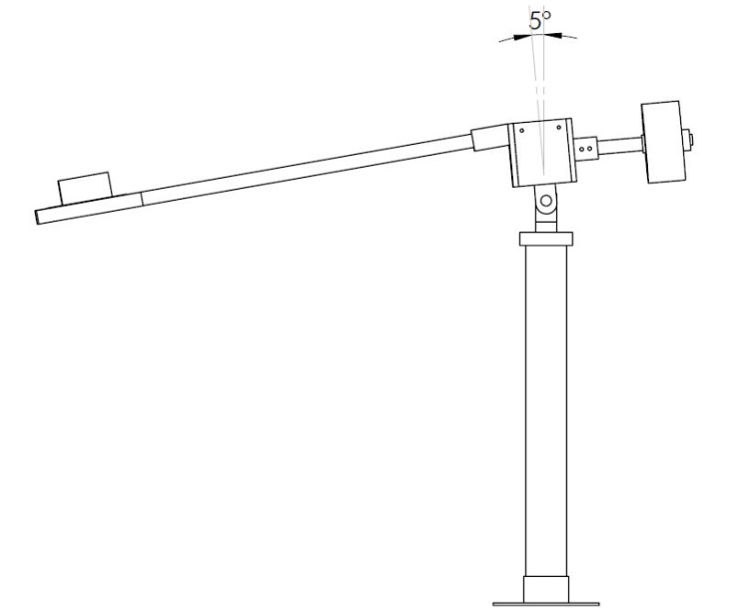

Fig. 3.1: Position 1 Fig. 3.2: Position 2

As shown in the above figure, the tray that carries the job is connected to a rotating assembly by means of an arm. A counterweight is attached diametrically to opposite arm. Both the arms, i.e., the tray and counterweight arm are free to revolve about an inclined axis. The entire revolving assembly is pivoted with its axis of revolution having a small inclination with the vertical.

The counterweight is selected such that it balances the weight of the empty tray at the topmost position (assuming negligible weight Fig. 6.1of arms). When the tray is empty, system has the tray arm at the top most position. When the part is kept on the tray moment on the tray side exceeds the moment at counterweight side and thus tries to attain a lower potential. This causes the tray to revolve by about the axis of rotation, which results in transfer of jobs between two stations.

Once the part reaches the destined station and is lifted, the moment at counterweight side becomes greater than the tray side. So now the counterweight which had reached its maximum attainable potential tries to return backs to its lowest potential, causing the assembly to revolve again to acquire the initial positions. Hence, the revolving tray moves from first station to second when a job is placed on it and returns back automatically to previous station once the job is removed from the tray. The system may work for any angle between - .

## Mathematical Analysis

Here, forces acting on the weight and counterweight are vertical, tangential and horizontal. But the force responsible for the motion is tangential in direction.

From the diagram we can see,

m1= mass of tray

m2= mass of counterweight Fig. 3.1

m= mass of object to be transferred

x= length of tray pipe

y= length of counterweight pipe

= angle of inclination of bearing block

Taking = angular acceleration about the axis X - X

Position 1(Fig. 3.1):

At initial position without any mass added on the tray,

Moment about O,

Tray side → mass = m1

Tangential acceleration in horizontal plane =

Tangential force = m1

Moment about X - X = =

Counterweight side → mass =

Tangential acceleration in horizontal plane =

Tangential force =

Moment about = =

For the motion to take place moment at tray should be less than moment at counterweight side.

……………… (1)

Position 2(Fig. 3.2):

After loading mass on the tray,

Moment about O,

Tray side → mass =

Tangential acceleration in horizontal plane =

Tangential force =

Moment about = =

Counterweight side → mass =

Tangential acceleration in horizontal plane =

Tangential force =

Moment about = =

Now, for the motion to take place moment at tray should be more than moment at counterweight side.

……………… (2)

Checking with the practical conditions:

Taking

we get

For the system to stay in Position 1 without any load on tray side the counterweight should be at least be

Now when a mass is placed on the tray, the system tends to rotate to Position 2. For this to happen it must satisfy equation (2).

Assuming the mass to be and checking equation (2),

For ,

Hence the system will rotate.

Later results are tabulated as follows,

|  |  |  |
| --- | --- | --- |
| Mass |  |  |
|  |  |  |
|  |  |  |
|  |  |  |

Table 3.1

From above table for every value of , it is seen that

Minimum value of for system to work as desired,

From equations (1) and (2),

It can be seen that for required system to work any mass greater than . But in practical use, considering friction a mass of can be assumed to be the lower limit.

# SYSTEM COMPONENTS

Parts can be listed as Bearing Housing which is mounted with the bearing at the center, main shaft on which the bearing housing is positioned, Tray and tray pipe, Counterweight and counterweight pipe, Base shaft, Base plate, damping system.

## Bearing Housing

Bearing housing comprises of 4 casing plates and a bearing block. The bearing block is a block of Plain Carbon Steel with dimensions of 100×100×32mm. It is provided with through holes for the bearings to fit in. The 4 casing plates are provided to enclose the bearings and the main shaft. The bearing block and the casing plates are provided with holes for Allen bolts to hold the casing plates together with the bearing block.

The casing plates each of dimensions 120×100×10mm are bolted with M6 Allen bolts. One casing plate is attached with stopper bracket for damping action, one with a tray pipe holder and one with counterweight pipe holder both welded to it.

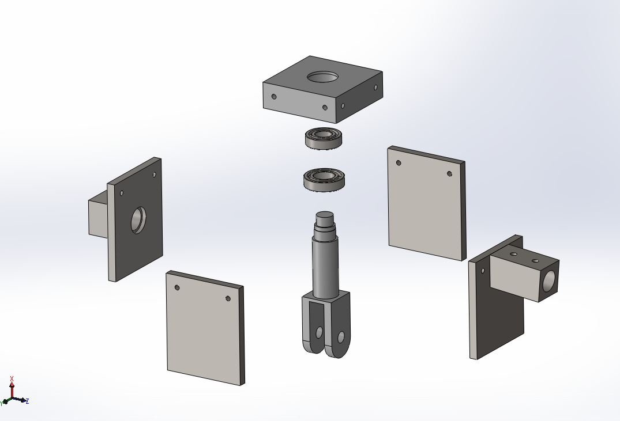

Fig. 4.1

## Main Shaft

Main shaft is that part of this system on which the bearing housing is mounted. One end of the shaft is provided with step turnings to place the bearings on it, which are packed in the bearing housing. At the other end of the shaft is a fork which will be placed on fork holder and bolted tight with a nut. Main shaft is the shaft over which a whole bearing housing rotates and creates the revolving motion. The main shaft is inclined at an angle to the vertical.

## Hinge Nut and Bolt

The fork of the main shaft is placed over the fork holder of the base shaft and is bolted with a bolt of diameter.

## Bearings

Considering the loads and forces acting two deep groove ball bearings are designed and selected to be placed inside the bearing housing. These bearings are acted upon by vertical and horizontal forces. The vertical forces can be considered as axial forces while the horizontal centrifugal forces can be said to be radial force acting upon the bearings. These bearings are the only moving parts of the system.

## Damper Bracket and spring

It is seen that at the end of each motion, due to the inertia of the heavy side, the setup tends to vibrate about the lowermost position. To avoid this a damper spring is added over the base shaft which absorbs some vibrations. Also a damper bracket is provided on one of the casing plates so that the return motion also stops without any vibrations.

## Base and Base Plate

The whole assembly is placed on a base shaft which is sturdy and rigid to some extent. This shaft has no other function other than providing some height for the system and transmitting any vibrations produced by the system to the ground via a base plate. The base plate is drilled with holes so the whole system can be bolted to ground and any further vibrations produced will be transmitted to the ground without any noticeable effects on the system.

## Tray and Counterweight

The tray is square shaped with a pipe welded to it which can be fixed to the bearing housing assembly by inserting the pipe into the tray pipe holder and fixing with Allen bolts. The counterweight is a set of deadweights placed on a shaft and held together by the counterweight shaft and a weight collar. This counterweight shaft, like the tray pipe, can be inserted in the counterweight pipe holder on another casing opposite to the tray pipe side and fixed with Allen bolts.

# CAD DESIGN AND DRAFTING

## 3-D Modeling Using Solidworks

Solidworks is the standard 3D product design, featuring industry leading productivity tool that promotes best practices in design while ensuring compliance with the industry and company standards. An integrated, parametric, 3D CAD/CAM/CAE solution allows you to design faster than ever, while maximizing innovation and quality to ultimately create exceptional products.

It is helpful in providing the designer with a 3-dimensional model of his design and enables him to add or delete certain useful or avoidable features in design.

## Benefits

* Automated generation of associative and manufacturing deliverables and

tooling design.

* Powerful, manufacturability and parametric design capabilities allow superior product differentiation.
* A design change in automatic propagation to all downstream deliverables allows you to design with confidence.
* Complete capabilities of virtual simulation enable you to improve product performance and exceed product quality goals.
* Fully integrated applications allow developing everything from concept to manufacturing within one application.

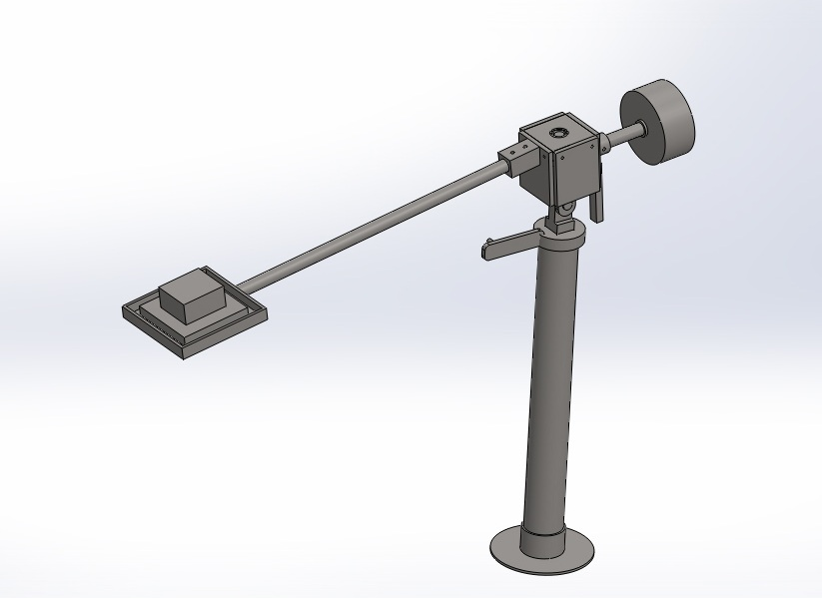

Fig. 5.1

# MATERIAL SELECTION

The material used in this project is cheap and also have enough strength for holding counterweight and the tray. So, in this case, we are using material en9 also known as plain carbon steel for places where there are high stresses such as main shaft, casing plate, fork and fork holder. Plain carbon steel is used because it is readily available and has high stress carrying capacity.

On the other hand, we use heavy counterweights, so the amount of mass is greater. Hence, cheap material should be used for it. So, ms steel is selected for this case. The base shaft and base plate are in no way affected by any forces so their strength does not matter, so cheap material like ms can be used for them. The material for tray pipe and counter weight pipe is also selected to reduce the cost. Hence, pipes made of ms steel are used for this purpose.

* Design and operations of material handling systems are applied OR and involving use of simulation, queuing theory, mathematical programming and network models.
* Examples of applications: Conveyor systems, pallet design and loading, equipment selection, dock design, equipment routing, packaging, and storage system design.
* The selection of material handling equipment and its assignment to departmental material-handling tasks: after an initial screening has been performed by the designer to determine the most promising candidates, the final selection is to be made analytically.
* Each move can be performed by most or all of the candidate equipment, thus for each move, there are different values for the operating cost and time based on the equipment used.
* The problem requires selection of equipment among the candidate set and assigning them to the moves such that a move is not made by more than one item of equipment unless they are of the same type (that is, each move is assigned to only one equipment type) and all moves assigned to a piece of equipment can be performed in the available time on the equipment.
* The primary objective of the problem is cost (operating and initial) minimization. There are also some secondary objectives such as maximum utilization of equipment and minimum variation in the selected types, but they are most often compatible with the primary objective.

## Design Of Main Shaft

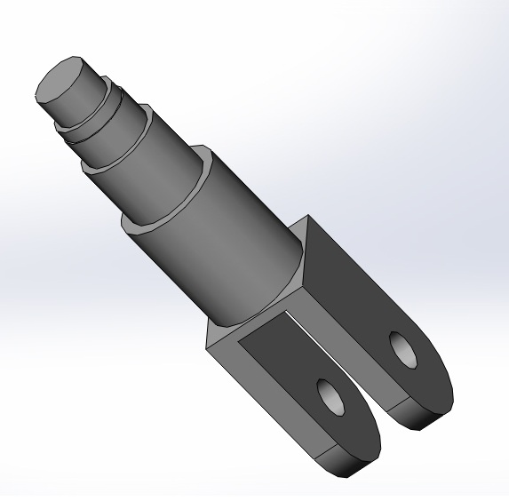Under compression

Fig. 6.1

Smallest section on shaft =

No torsion on main shaft, because of bearing.

Check for direct shear on main shaft:

Hence, to avoid shear.

## C:\Users\Nikhil\Desktop\6004 bearing.JPGDesign Of Bearings

### Bearing 1

Assuming deep groove ball bearing.

Having

Fig. 6.2

For deep groove ball bearing

Assuming service time to be hrs.

Assuming

Hence design is safe.

For stability & to avoid wobbling movement using another bearing

### Bearing 2

Assuming other bearing of higher diameter

For deep groove ball bearing

Assuming service time to be

Assuming

Hence design is safe.

## Design Of Bearing Block

Material used EN9 (Plain Carbon Steel).

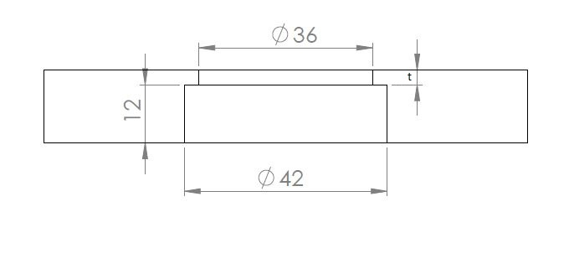

Fig. 6.3

Assuming

Total thickness of bearing block

CHECKING

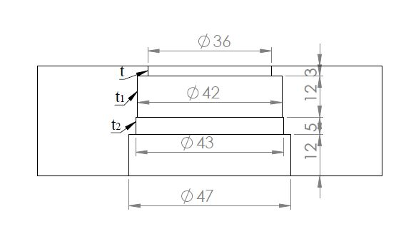

Hence design is safe.

CHECKING

Fig. 6.4

Hence design is safe.

## Design Of Bolt

### On Tray Side

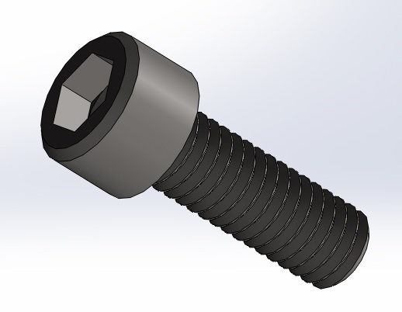Assuming data,

Fig. 6.5

Shear Stress in Bolt:

Tensile Force in Bolt:

Tensile Stress in Bolt:

Principal Stress

Assuming principal Stress to be

From PSG pg 5.42

Selecting M6 Bolt having

### On Counterweight Side

Assuming data,

Tensile Force in Bolt:

Shear Stress in Bolt:

Tensile Force in Bolt:

Tensile Stress in Bolt:

Principal Stress

Assuming principal Stress to be

Cross-section area of M6 bolt

Hence, design is safe.

### Design of Hinge Bolt

Assuming plain carbon steel,

(From PSG 1.14)

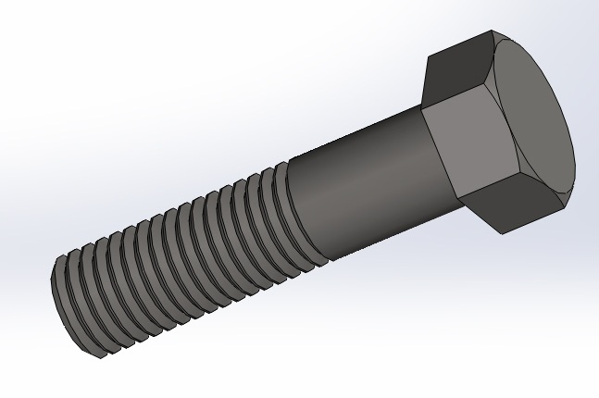

Fig. 6.6

Taking

## Weld Design

### Countershaft Holder

Data assumed

Considering shear stress:

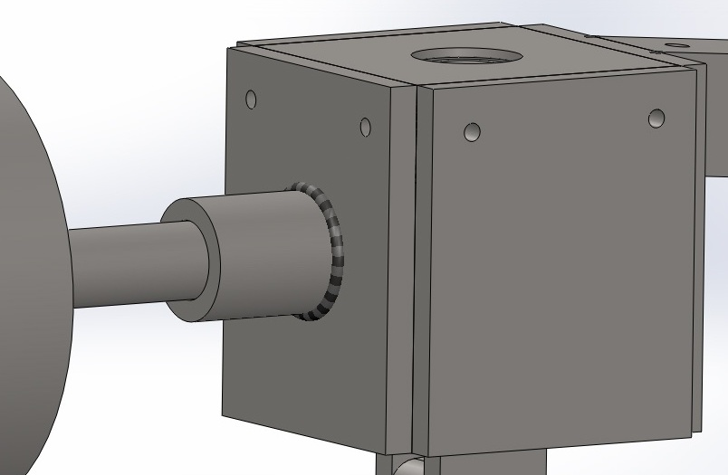

Considering bending stress:

Fig. 6.7

By maximum shear stress theory,

Assuming allowable max. shear stress to be

### Tray Pipe Holder

Data assumed

Considering shear stress:

Considering bending stress:

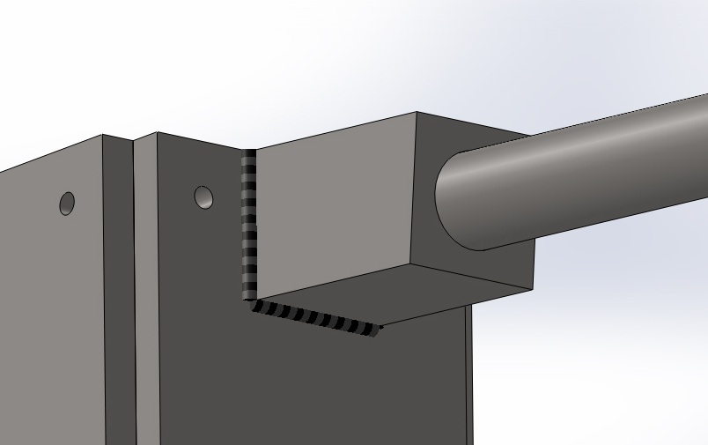

Fig. 6.8

By maximum shear stress theory,

Assuming allowable max. shear stress to be

# FABRICATION

## Process Sheets

|  |  |  |  |  |  |  |  |  |  |
| --- | --- | --- | --- | --- | --- | --- | --- | --- | --- |
| **PART NO : RMT-03** | | | | | **MATERIAL SPECIFICATION: PLAIN CARBON STEEL** | | | | |
| **PART NAME : MAIN BEARING HSG** | | | | | **RAWMATERIAL SIZE: 110 X 110 X 40** | | | | |
|  | | | | | **QUANTITY :- 01 NO’S.** | | | | |
| **Sr. No.** | **Description of Operation** |  | **Tools** | | | | **Time in minutes** | | |
|  |  | **Jigs & Fixture** | **M/c Tools** | **Cutting Tools** | | **Measuring Instrument** | **Setting Time** | **M/c Time** | **Total Time** |
| 1 | Facing All Sides Sq. to total length 100x100x32 | M/c vice | Milling | Facing cutter | | Vernier | 15 | 20 | 35 |
| 2 | Drilling Ø 18.5 through thickness | 4 Jaw chuck | Lathe | Twist drill | | Vernier | 10 | 8 | 18 |
| 3 | Boring Ø 36 through thickness | 4 Jaw chuck | Lathe | Boring tool | | Vernier | 8 | 8 | 16 |
| 4 | Counter Boring Ø 42 through 29 thickness | 4 Jaw chuck | Lathe | Boring tool | | Vernier | - | 10 | 10 |
| 5 | Counter Boring Ø 43 through 17 thickness | 4 Jaw chuck | Lathe | Boring tool | | Vernier | - | 10 | 10 |
| 6 | Drilling Ø5 through 10 thickness 10no’s | M/c vice | Drilling | Twist drill | | Vernier | 10 | 10 | 20 |

Table 7.1

|  |  |  |  |  |  |  |  |  |  |
| --- | --- | --- | --- | --- | --- | --- | --- | --- | --- |
| **PART NO : RMT-04, 05, 06** | | | | | **MATERIAL SPECIFICATION: Plain Carbon Steel RAWMATERIAL SIZE: 120×450×10** | | | | |
| **PART NAME : CASING PLATE** | | | | | **QUANTITY - 03 no’s.** | | | | |
| **Sr. No** | **Description of Operation** |  | **Tools** | | | | **Time in minutes** | | |
|  |  | **Jigs & Fixture** | **M/c Tools** | **Cutting Tools** | | **Measuring Instrument** | **Setting Time** | **M/c Time** | **Total Time** |
| 1 | Cutting plate to size 120×102×10 | M/c vice | Hacksaw cutter | Hacksaw | | Vernier | 7 | 10 | 17 |
| 2 | Finishing the workpiece to 120×100×10 | M/c vice | Grinding machine | Grinder stone | | Vernier | 10 | 10 | 20 |
| 3 | Drilling Ø 6 2no’s | M/c Vice | Drilling | Twist Drill | | Vernier | 5 | 7 | 12 |

Table 7.2

|  |  |  |  |  |  |  |  |  |
| --- | --- | --- | --- | --- | --- | --- | --- | --- |
|  | | | | | **MATERIAL SPECIFICATION: PLAIN CARBON STEEL** | | | |
| **PART NO : RMT-07** | | | | | **RAWMATERIAL SIZE: 120×450×10** | | | |
| **PART NAME : CASING PLATE-04** | | | | | **QUANTITY :- 01 NO’S.** | | | |
| **Sr. No.** | **Description of Operation** |  | **Tools** | | | **Time in minutes** | | |
|  |  | **Jigs & Fixture** | **M/c Tools** | **Cutting Tools** | **Measuring Instrument** | **Setting Time** | **M/c Time** | **Total Time** |
| 1 | Cutting plate to size 120×101×10 | M/c vice | Hacksaw cutter | Hacksaw | Vernier | 7 | 10 | 17 |
| 2 | Finishing the workpiece to 120×100×10 | M/c vice | Grinding | Grinder stone | Vernier | 5 | 7 | 12 |
| 3 | Drilling Ø 6 2no’s | M/c Vice | Drilling | Twist Drill | Vernier | 5 | 5 | 25 |
| 4 | Drilling Ø 18.5 through thickness | 4 Jaw chuck | Lathe | Twist drill | Vernier | 10 | 4 | 14 |
| 5 | Boring Ø 32 through thickness | 4 Jaw chuck | Lathe | Boring tool | Vernier | 5 | 8 | 13 |

Table 7.3

|  |  |  |  |  |  |  |  |  |  |
| --- | --- | --- | --- | --- | --- | --- | --- | --- | --- |
| **PART NO : RMT-08** | | | | | **MATERIAL SPECIFICATION: PLAIN CARBON STEEL** | | | | |
| **PART NAME : MAIN SHAFT** | | | | | **RAWMATERIAL SIZE: 50 X 50 X 180** | | | | |
|  | | | | | **QUANTITY :- 01 NO’S.** | | | | |
| **Sr. No.** | **Description of Operation** |  | **Tools** | | | | **Time in minutes** | | |
|  |  | **Jigs & Fixture** | **M/c Tools** | **Cutting Tools** | | **Measuring Instrument** | **Setting Time** | **M/c Time** | **Total Time** |
| 1 | Facing All Sides Sq. to total length 40x40x169 | M/c vice | Milling M/c | Facing cutter | | Vernier | 5 | 12 | 17 |
| 2 | Step Turning OD to Ø 38 through length 99 | 4 Jaw chuck | Lathe | Turning tool | | Vernier | 12 | 14 | 26 |
| 3 | Step Turning OD to Ø 30 through length 69 | 4 Jaw chuck | Lathe | Turning tool | | Vernier | - | 7 | 7 |
| 4 | Step Turning OD to Ø 25 through length 29 | 4 Jaw chuck | Lathe | Turning tool | | Vernier | - | 6 | 6 |
| 5 | Step Turning OD to Ø 24 through length 17 | 4 Jaw chuck | Lathe | Turning tool | | Vernier | - | 6 | 6 |
| 6 | Step Turning OD to Ø 20 through length 12 | 4 Jaw chuck | Lathe | Turning tool | | Vernier | - | 6 | 6 |
| 7 | Drilling Ø 16 | M/c Vice | Drilling | Twist Drill | | Vernier | 5 | 10 | 15 |
| 8 | Milling flat as per profile | M/c Vice | Milling | Facing cutter | | Vernier | 10 | 15 | 25 |

Table 7.4

|  |  |  |  |  |  |  |  |  |  |
| --- | --- | --- | --- | --- | --- | --- | --- | --- | --- |
| **PART NO : RMT-14** | | | | | **MATERIAL SPECIFICATION: PLAIN CARBON STEEL** | | | | |
| **PART NAME : CW SHAFT HOLDER** | | | | | **RAW MATERIAL SIZE:  50X 60** | | | | |
|  | | | | | **QUANTITY :- 01 NO’S.** | | | | |
| **Sr. No.** | **Description of Operation** |  | **Tools** | | | | **Time in minutes** | | |
|  |  | **Jigs & Fixture** | **M/c Tools** | **Cutting Tools** | | **Measuring Instrument** | **Setting Time** | **M/c Time** | **Total Time** |
| 1 | Facing Both side to total length 50 | Three jaw chuck | Lathe | Facing | | Vernier | 5 | 5 | 10 |
| tool | |
| 2 | Turning OD Ø 42 through length | Three jaw chuck | Lathe | Turning tool | |  | 3 | 8 | 11 |
| 3 | Step Turning OD to Ø 32 through length 5 | Three jaw chuck | Lathe | Turning tool | | Vernier | - | 8 | 8 |
|
| 4 | Drilling Ø 15 through thickness | Three jaw chuck | Lathe | Twist drill | | Vernier | 7 | 8 | 15 |
| 5 | Boring Ø 25.4 through thickness | Three jaw chuck | Lathe | Boring tool | | Vernier | 5 | 7 | 12 |
| 6 | Drilling Ø 6.8 -2 no’s | M/c vice | Drilling | Twist Drill | |  | 5 | 4 | 9 |

Table 7.5

|  |  |  |  |  |  |  |  |  |  |
| --- | --- | --- | --- | --- | --- | --- | --- | --- | --- |
| **PART NO : RMT-13** | | | | | **MATERIAL SPECIFICATION: PLAIN CARBON STEEL** | | | | |
| **PART NAME : TRAY PIPE HOLDER** | | | | | **RAWMATERIAL SIZE: 50X 50 X 70** | | | | |
|  | | | | | **QUANTITY :- 01 NO’S.** | | | | |
| **Sr. No.** | **Description of Operation** |  | **Tools** | | | | **Time in minutes** | | |
|  |  | **Jigs & Fixture** | **M/c Tools** | **Cutting Tools** | | **Measuring Instrument** | **Setting Time** | **M/c Time** | **Total Time** |
| 1 | Facing All Sides Sq. to total length 40x40x70 | M/c vice | Milling | Facing cutter | | Vernier | 7 | 14 | 21 |
| 2 | Drilling Ø18.5 through | 4 Jaw chuck | Lathe | Twist Drill | | Vernier | 7 | 7 | 14 |
| 3 | Drilling Ø 25.4 through thickness | 4 Jaw chuck | Lathe | Boring tool | | Vernier | 5 | 6 | 11 |
| 4 | Drilling Ø 6.8 - 2no’s | M/c Vice | Drilling | Twist Drill | | Vernier | 4 | 3 | 7 |
| 5 | Tapping M8 | Vice |  | Hand tap | |  | 7 | 15 | 22 |
| 6 | Milling Flat as per profile | M/c vice | Milling | Facing cutter | | Vernier | 12 | 10 | 22 |

Table 7.6

|  |  |  |  |  |  |  |  |  |  |
| --- | --- | --- | --- | --- | --- | --- | --- | --- | --- |
| **PART NO : RMT-15** | | | | | **MATERIAL SPECIFICATION: PLAIN CARBON STEEL** | | | | |
| **PART NAME : CW SHAFT** | | | | | **RAW MATERIAL SIZE:  40X 250** | | | | |
|  | | | | | **QUANTITY :- 01 NO’S.** | | | | |
| **Sr. No.** | **Description of Operation** |  | **Tools** | | | | **Time in minutes** | | |
|  |  | **Jigs & Fixture** | **M/c Tools** | **Cutting Tools** | | **Measuring Instrument** | **Setting Time** | **M/c Time** | **Total Time** |
| 1 | Facing Both side to total length 245 | Three jaw chuck | Lathe | Facing | | Vernier | 7 | 5 | 12 |
| tool | |
| 2 | Turning OD Ø34 through length | Three jaw chuck | Lathe | Turning tool | | Vernier | 3 | 12 | 15 |
| 3 | Step Turning OD to Ø 26 through length 136 | Three jaw chuck | Lathe | Turning tool | | Vernier | - | 10 | 10 |
|
| 4 | Step Turning OD to Ø 20 through length 100 | Three jaw chuck | Lathe | Turning tool | | Vernier | - | 8 | 8 |
|
| 5 | Drilling Ø 15 through thickness 140 | Three jaw chuck | Lathe | Twist drill | | Vernier | 5 | 14 | 19 |

Table 7.7

|  |  |  |  |  |  |  |  |  |
| --- | --- | --- | --- | --- | --- | --- | --- | --- |
| **PART NO : RMT-16** | | | | | **MATERIAL SPECIFICATION: PLAIN CARBON STEEL** | | | |
| **PART NAME : CW RETAINER** | | | | | **RAW MATERIAL SIZE:  50X 30** | | | |
|  | | | | | **QUANTITY :- 01 NO’S.** | | | |
| **Sr. No.** | **Description of Operation** |  | **Tools** | | | **Time in minutes** | | |
|  |  | **Jigs & Fixture** | **M/c Tools** | **Cutting Tools** | **Measuring Instrument** | **Setting Time** | **M/c Time** | **Total Time** |
| 1 | Facing Both side to total length 20 | Three jaw chuck | Lathe | Facing | Vernier | 5 | 4 | 9 |
| tool |
| 2 | Turning OD Ø 40 through length | Three jaw chuck | Lathe | Turning tool |  | 5 | 7 | 12 |
| 3 | Drilling Ø 15 through thickness | Three jaw chuck | Lathe | Twist drill | Vernier | 5 | 5 | 10 |
| 4 | Boring Ø 20 through thickness | Three jaw chuck | Lathe | Boring tool | Vernier | 5 | 5 | 10 |
| 5 | Drilling Ø 6.8 | M/c vice | Drilling | Twist Drill |  | 3 | 2 | 5 |
| 6 | Tapping M8 | Vice |  | Hand tap |  | 5 | 12 | 17 |

Table 7.8

|  |  |  |  |  |  |  |  |  |
| --- | --- | --- | --- | --- | --- | --- | --- | --- |
| **PART NO : RMT-21** | | | | **MATERIAL SPECIFICATION: MILD STEEL** | | | | |
| **PART NAME : SPRING HOLDER** | | | | **RAW MATERIAL SIZE: A/F 17 HEX × 110** | | | | |
| **Sr.** | **Description of Operation** |  | **Tools** | | | **Time in minutes** | | |
| **No** |
|  |  | **Jigs & Fixture** | **M/c Tools** | | **Cutting Tools** | **Setting Time** | **M/c Time** | **Total Time** |
| 1 | Facing Both side to total length 103 | Three jaw chuck | Lathe | | Facing | 5 | 5 | 10 |
| tool |
| 2 | Turning OD Ø16 through length 73 | Three jaw chuck | Lathe | | Turning tool | 2 | 7 | 9 |
| 3 | Step Turning OD to Ø 11 through length 15 | Three jaw chuck | Lathe | | Turning tool | - | 8 | 8 |

Table 7.9

|  |  |  |  |  |  |  |  |  |
| --- | --- | --- | --- | --- | --- | --- | --- | --- |
| **PART NO : RMT-21** | | | **MATERIAL SPECIFICATION: PLAIN CARBON STEEL** | | | | | |
| **PART NAME : DAMPER BRACKET** | | | **RAW MATERIAL SIZE:  120X 35** | | | | | |
|  | | | **QUANTITY :- 01 NO’S.** | | | | | |
| **Sr. No.** | **Description of Operation** |  | | **Tools** | | **Time in minutes** | | |
|  |  | **Jigs & Fixture** | | **M/c Tools** | **Cutting Tools** | **Setting Time** | **M/c Time** | **Total Time** |
| 1 | Facing Both side to total length 30 | Three jaw chuck | | Lathe | Facing | 5 | 5 | 10 |
| tool |
| 2 | Turning OD Ø 112 through length | Three jaw chuck | | Lathe | Turning tool | 5 | 10 | 15 |
| 3 | Drilling Ø 25 through thickness | Three jaw chuck | | Lathe | Twist drill | 5 | 7 | 12 |
| 4 | Boring Ø 84 Through thickness | Three jaw chuck | | Lathe | Boring tool | 10 | 15 | 25 |
| 5 | Counter Boring Ø 94 Through thickness 24 | Three jaw chuck | | Lathe | Boring tool | - | 10 | 10 |
| 6 | Drilling Ø 6.8 | M/c vice | | Drilling | Twist Drill | 5 | 8 | 13 |
| 7 | Tapping M8 | Vice | |  | Hand tap | 5 | 12 | 17 |

Table 7.10

|  |  |  |  |  |  |  |  |  |  |
| --- | --- | --- | --- | --- | --- | --- | --- | --- | --- |
|  | | | | |  | | | | |
| **PART NO : RMT-16** | | | | | **MATERIAL SPECIFICATION: PLAIN CARBON STEEL** | | | | |
| **PART NAME : COUNTER WEIGHT** | | | | | **RAW MATERIAL SIZE:  160X 75** | | | | |
|  | | | | | **QUANTITY :- 01 NO’S.** | | | | |
| **Sr. No.** | **Description of Operation** |  | **Tools** | | | | **Time in minutes** | | |
|  |  | **Jigs & Fixture** | **M/c Tools** | **Cutting Tools** | | **Measuring Instrument** | **Setting Time** | **M/c Time** | **Total Time** |
| 2 | Facing Both side to total length 70mm | Three jaw chuck | Lathe | Facing | | Vernier | 5 | 10 | 10 |
| tool | |
| 3 | Turning OD Ø 150mm through length | Three jaw chuck | Lathe | Turning tool | | Vernier | 5 | 12 | 17 |
| 4 | Drilling Ø 15 through thickness | Three jaw chuck | Lathe | Twist drill | | Vernier | 5 | 8 | 20 |
| 5 | Boring Ø 20 through thickness | Three jaw chuck | Lathe | Boring tool | | Vernier | 6 | 8 | 22 |

Table 7.11

|  |  |  |  |  |  |  |  |  |  |
| --- | --- | --- | --- | --- | --- | --- | --- | --- | --- |
|  | | | | | **MATERIAL SPECIFICATION: MILD STEEL RAWMATERIAL SIZE: 150×40×10** | | | | |
| **PART NO : RMT -23** | | | | |
| **PART NAME : DAMPER BRACKET HOLDER** | | | | |
| **Sr. No.** | **Description of Operation** |  | **Tools** | | | | **Time in minutes** | | |
|  |  | **Jigs & Fixture** | **M/c Tools** | **Cutting Tools** | | **Measuring Instrument** | **Setting Time** | **M/c Time** | **Total Time** |
| 1 | Facing according to profile | M/c vice | Milling | Facing | | Vernier | 7 | 10 | 17 |
| 2 | Grinding of edges |  | Grinding machine | Grinder stone | |  | 2 | 10 | 12 |
| 3 | Drilling of holes | M/c Vice | Drilling | Twist Drill | | Vernier | 5 | 12 | 17 |

Table 7.12

## Bill Of Material

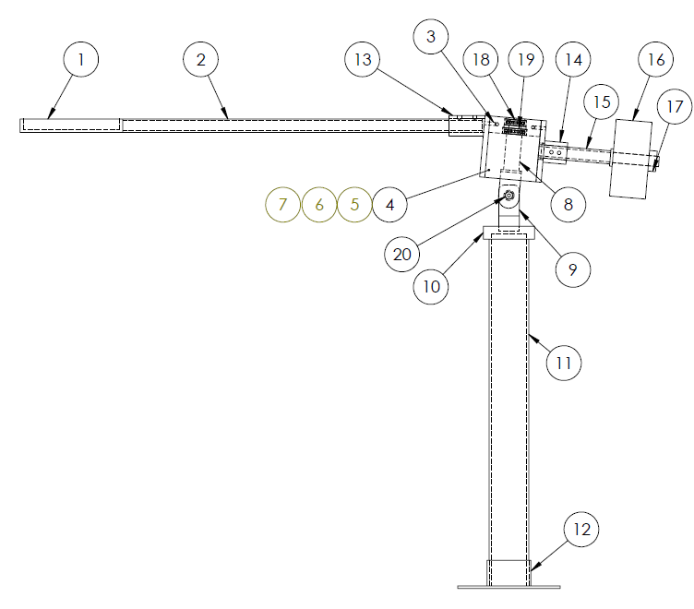

Fig. 7.1

|  |  |  |  |  |
| --- | --- | --- | --- | --- |
| **SR NO.** | **PART CODE** | **DESCRIPTION** | **QTY** | **MATERIAL** |
| 1. | RMT -1 | TRAY | 1 | MS |
| 2. | RMT -2 | TRAY PIPE | 1 | MS |
| 3. | RMT -3 | MAIN BEARING BLOCK | 1 | PCS |
| 4. | RMT -4 | CASING PLATE-01 | 1 | PCS |
| 5. | RMT -5 | CASING PLATE-02 | 1 | PCS |
| 6. | RMT -6 | CASING PLATE-03 | 1 | PCS |
| 7. | RMT -7 | CASING PLATE-04 | 1 | PCS |
| 8. | RMT –8 | MAIN SHAFT | 1 | PCS |
| 9. | RMT –9 | FORK HOLDER | 1 | PCS |
| 10. | RMT –10 | FORK HOLDER COLLAR | 1 | PCS |
| 11. | RMT –11 | BASE PIPE | 1 | MS |
| 12. | RMT –12 | BASE FLANGE | 1 | MS |
| 13. | RMT –13 | TRAY PIPE HOLDER | 1 | PCS |
| 14. | RMT –14 | CW SHAFT HOLDER | 1 | PCS |
| 15. | RMT –15 | CW SHAFT | 1 | PCS |
| 16. | RMT –16 | COUNTER WEIGHT (CW) | 1 | MS |
| 17. | RMT –17 | COUNTER WEIGHT RETAINER | 1 | MS |
| 18. | RMT –18 | BEARING 6004 | 1 | STD |
| 19. | RMT –19 | BEARING 6005 | 1 | STD |
| 20. | RMT -20 | 16×75 BOLT | 1 | STD |
| 21. | RMT -21 | SPRING HOLDER | 1 | MS |
| 22. | RMT -22 | DAMPER BRACKET | 1 | MS |
| 23. | RMT -23 | NYLON STOPPER | 1 | NYLON |
| 24. | RMT -24 | SPRING | 1 | MS |
| 25. | RMT -25 | ALLEN BOLT 6×20 | 8 | STD |
| 26. | RMT -26 | ALLEN BOLT 8×12 | 5 | STD |
| 27. | RMT -26 | HEX BOLT 8×12 | 2 | STD |

Table 7.13

|  |
| --- |
|  |
| Fig. 7.2: Bearing Block |
|  |
| Fig. 7.3: Base Assem |
|  |
| Fig. 7.4: CW Assembly |
|  |
| Fig. 7.5: Base |
|  |
| Fig. 7.6: Casing Plate |
|  |
| Fig. 7.7: CW Shaft Holder |
|  |
| Fig. 7.8: Tray Pipe Holder |
|  |
| Fig. 7.9: Tray Pipe |
|  |
| Fig. 7.10: Main Shaft |

## Cost Estimation

**Cost of raw material**

Cost of Purchased Part

|  |  |  |  |
| --- | --- | --- | --- |
| **Item** | **Cost per piece** | **Quantity** | **Total** |
| 6×20 Allen bolt | 3 | 8 | 24 |
| 8×12 Allen Bolt | 4 | 5 | 20 |
| 8×12 HT bolt | 2 | 2 | 4 |
| Spring | 27 | 1 | 27 |
| 8×10 Grub screw | 4 | 1 | 4 |
| 4×8 Grub screw | 3 | 1 | 3 |
| 16×75 HT bolt with locknut and 2 washers | 42 | 1 | 42 |
| Bearing 6004 | 70 | 1 | 70 |
| Bearing 6005 | 80 | 1 | 80 |
|  |  | **Total** | 274 |
| Table 7.14 | | | |

Machining Cost

|  |  |  |  |  |  |
| --- | --- | --- | --- | --- | --- |
| Operation | Operating rate per hour | Idle Rate per hour | Operating hours | Setting time hours | Total cost in Rs. |
| Lathe | 380 | 100 | 5hr 51min | 3hr 8min | 2223 |
| Milling | 390 | 100 | 1hr 13min | 47min | 474.5 |
| Hacksaw | 150 | 50 | 40min | 28min | 123.33 |
| Grinder | 170 | 50 | 28min | 20min | 96 |
| Total | | | | | 2916.83 |

Table 7.15

Miscellaneous Cost

Welding Cost: Rs.150

Tapping Cost: Rs.150

Painting Cost: Rs. 400

# FUTURE SCOPE

## Telescopic Arm

The tray pipe length can be adjusted, so as to deliver the load at different distances. This can be done by replacing the conventional arm for tray pipe by a telescopic arm. The arm length increases the mass of load delivered, should be reduced and vice versa.

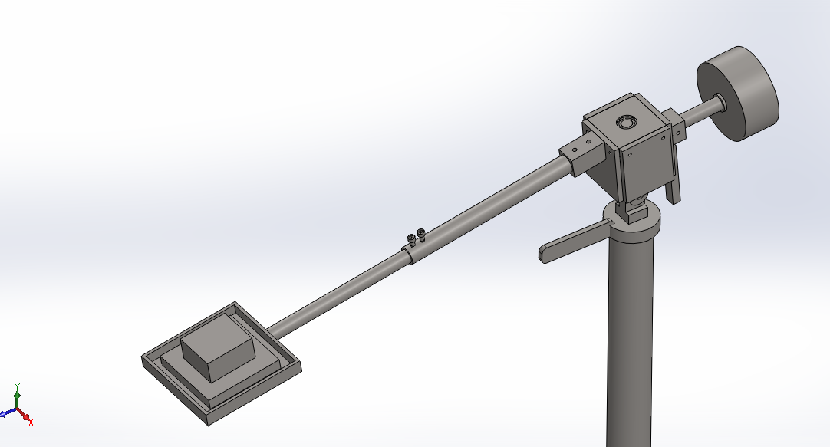

Fig. 8.1

## Adjustable Weight

The counterweight can be adjusted such like to deliver the correct amount of load. Adjustable counterweights can be selected, depending on the mass of the object placed on the tray.

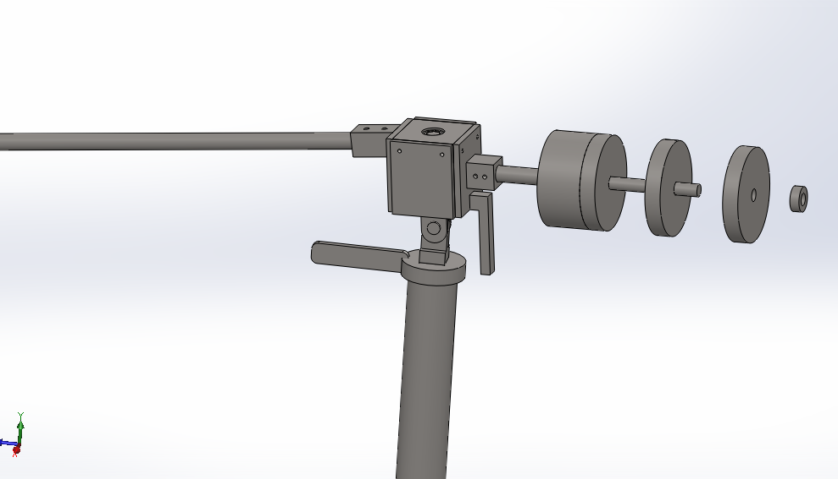

Fig. 8.2

## Ceiling Attachment

The unit can be attached to ceiling and it is inverted to improve space utilization. Also when attached to ceiling with larger span of tray pipe, then large distance material transfer can be achieved.

## Combination of Telescopic and Adjustable Counterweight

A combination of both telescopic arm and adjustable counterweight can be introduced, to deliver the same amount of load over different distances.

## Automatic Delivery

The tray can be so designed so as to deliver the load automatically to the delivery side.

## Modifications of Tray

Various modifications can be done to the tray. Some of them can be mentioned as the tray can be provided with an automatic opening tray in which the bottom of the tray opens when the tray reaches the final delivery position. Also for unevenly shaped products, the tray can be made of leather or even the tray can be replaced with a vessel which can also be used for liquid or semi-solid materials. For bulky products a hook can be provided which can be easily loaded or unloaded.

# ADVANTAGES AND APPLICATION

## Advantages

* It requires low fabrication.
* Also, it has low running and maintenance cost.
* Reduces operators handling thus reduces operators fatigue.
* Robust, simple, compact and flexible design makes it suitable for almost all short distance material transfer application.
* Consumes no electrical power as works on counterweight principle.
* The effective productive time increases as the operator can utilize time for loading or unloading jobs from machine which was otherwise wasted material transfer.
* As the material transfer can be done by machine, it saves operator’
* If intelligently mounted online, it does not block the passages for operator’s movement.

## Applications

* It can be used in jobs hop to transfer material between two work stations.
* It can be useful in small scale industry to transfer material over short distances.
* The concept can be used to develop civil cranes to transport material to the construction area.
* Can be used in warehouses and docks for loading and unloading purpose.
* It can be useful in packaging industry.
* It is useful only in small areas.

# CONCLUSION

The design of the system for conveyor with the consideration of the parameters to improve the performance of the system is the key objective of presenting this paper. Authors have carried out the analysis of the said system and results are presented in this paper. Authors are working further for better implementation of the automation in small industries at lowest investment. The partial automated processes are useful for small industries as the cost for implementation is significantly less and saving is effective in terms of the cost.

After the fabrication and implementation of the effective material handling system, one could easily demonstrate the improved material handling. “Revolving Material Transfer Systems” shows how some simple and innovative ideas can be used to develop cheap and non-power consuming material transfer systems that can significantly relieve the operator fatigue make the material transfer safer along with the increased productivity.

The project was just an effort to demonstrate the need and means of improving the material transfer systems and highlight the future scope of effective material transfer.

**PUBLICATION BASED ON THE REPORT**

**INTERNATIONAL JOURNAL (PUBLISHED)**

Mr. Santosh Lokhande, Mr. Sunil Pagare, Dr. S. Ram Reddy, “DESIGN OF GRAVITY BASED MATERIAL CONVEYOR EQUIPMENT,” NOVATEUR PUBLICATIONS JournalNX- A Multidisciplinary Peer Reviewed Journal ISSN No:2454-7875 VOLUME 4, ISSUE 1, Jan. -2018.

# REFERENCES

* Ms. Vrushali R. Rajmane, Mr. ChandrakantR.Sonawane,"Design, Development And Analysis Active Gravity Conveyor For Flexible Manufacturing Using Karakuri Mechanism", International Engineering Research Journal (IERJ) Special Issue 2 Page 2825-2831, 2015, ISSN 2395-1621, published date 22/11/2015.
* Konakalla Naga Sri Ananth1 , Vaitla Rakesh2 , Pothamsetty Kasi Visweswarao3Research Paper "DESIGN AND SELECTING THE PROPER CONVEYOR-BELT" Ananth et al., International Journal of Advanced Engineering Technology E-ISSN 0976-3945 IJAET/Vol. IV/ Issue II/April-June, 2013/43-49
* Industrial Engineering Prof. Inderdeep Singh Department of Mechanical and Industrial Engineering Indian Institute of Technology, Roorkee, "Materials Handling" Module - 4 Lecture - 15 Materials Handling.
* Vikas Gupta, Rajesh Bansal, Vineet Kumar Goel, “A REVIEW ON MATERIAL HANDLING EQUIPMENTAND THEIR SELECTION FOR POTENTIALAPPLICATIONS” International Journal of Technical Research(IJTR)Vol. 2, Issue 1, Mar-Apr 2013
* Michael G. Kay Fitts “Material Handling Equipment”, Dept. of Industrial and Systems Engineering North Carolina State University January 12, 2012.
* Dr. Tauseef Aized Professor “Materials handling in flexible manufacturing systems” Department of Mechanical, Mechatrnics and Manufacturing Engineering, KSK Campus, University of Engineering and Technology, Lahore, Pakistan
* Mr.Amol B.Kharage*, Prof. Balaji Nelge, Prof. Dhumal Ketan “ANALYSIS AND OPTIMIZATION OF GRAVITY ROLLER CONVEYOR USING ANSYS” PG Student, M.E. (Design Engg.), Department of Mechanical Engineering, Dhole Patil college of Engineering, Wagholi, Pune, India
* 1Satish Vithoba Gaikwad, 2N.S. Kulkarni, 3Swapnil S. Kulkarni “DYNAMIC ANALYSIS & WEIGHT OPTIMIZATION OF ROLLER CONVEYOR WEIGHT OPTIMIZATION & MATERIAL SAVING” International Journal of Advanced Engineering Research and Studies E-ISSN2249–8974
* S.H. Masood · B. Abbas · E. Shayan · A. Kara “An investigation into design and manufacturing of mechanical conveyors systems for food processing” Received: 29 March 2003 / Accepted: 21 June 2003 / Published online: 23 June 2004 D.K. Nannaware [1], R.R. Kharde [2]
* PG student, Pravara Rural Engineering College,Loni, India. [1] Professor, Pravara Rural Engineering College,Loni, India “Design and Optimization of Roller Conveyor System” International Journal of Scientific & Engineering Research, Volume 5, Issue 7, July-2014 1254 ISSN 2229-5518